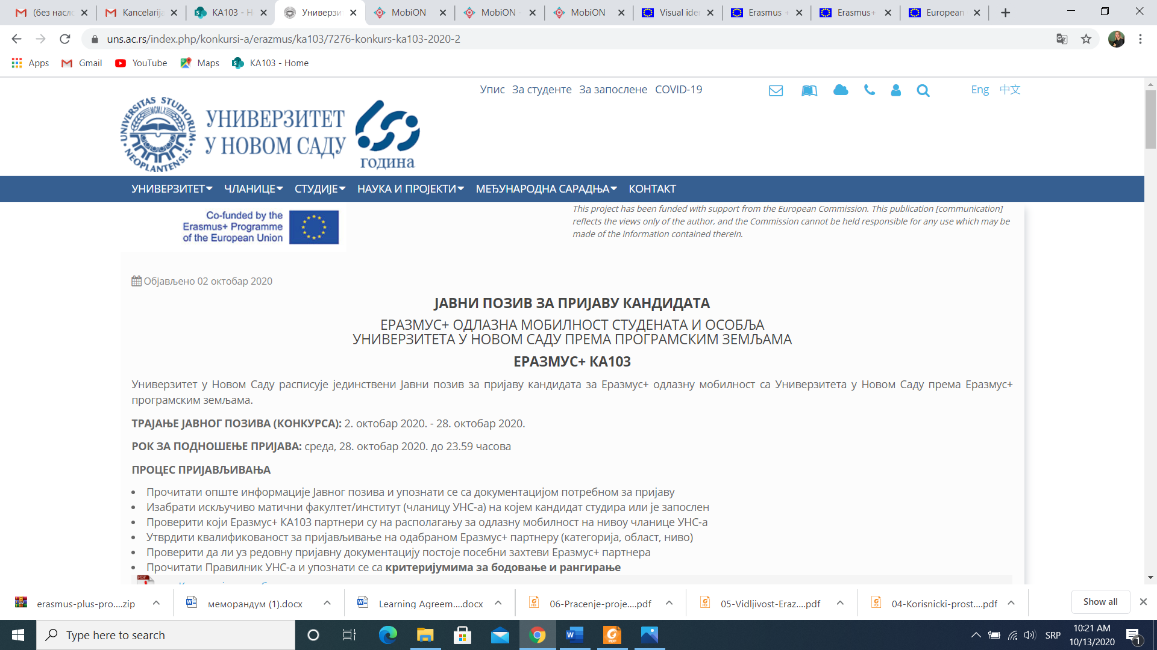

|  |  |  |
| --- | --- | --- |
| No. | Target groups for inclusion | Accompanying documents |
| 1 | Serious chronic diseases (systemic diseases, cancer, dyslexia, dysgraphia, etc.) | A document issued by the National Employment Service or another government authority which confirms the health condition. If not applicable, it is necessary to provide a report of a specialist (a doctor, psychologist etc.) confirming the health condition. |
| 2 | Persons on welfare / Persons whose family is on welfare | A certificate of a Social Welfare Centre or another government authority which confirms that the person receives welfare support during the mobility preparation period, after being selected in the application call |
| 3 | Persons living in underdeveloped, devastated and least developed municipalities of the partner HEI country | A copy of the ID containing the residence address; a copy of the passport in case of minors |
| 4 | Persons from disadvantaged socio-economic background[1] | **A certificate on the average monthly income per household member** issued by the municipality where the person has their residence address, as indicated in the ID or any other document issued by the competent authority which shows the residence address of the person. |
| 5 | Single parents (single-parent families) | * A death certificate for the other parent or a declaration of a missing person’s death * A birth certificate for children of undetermined paternity, a document issued by a correctional institution stating that the other parent has been in prison for more than six months |
| 6 | Persons with three or more children | * Proof of receiving child benefit for the third, fourth or any subsequent child |
| 7 | Persons without parents under the age of 26 | * Death certificates for both parents * A copy of the ID as proof of age for persons aged 18 years or older |
| 8 | Persons in foster care/guardian families or social welfare institutions under the age of 26 | * A certified copy of a Decision on guardianship issued by a Social Welfare Centre * An Agreement on foster care or a certified copy of a Decision on foster care placement issued by a Social Welfare Centre |
| 9 | Persons living in families with three or more children | * Birth certificates for all the children * A certificate issued by the relevant municipality stating that the children live at the same address or a copy of the ID showing the address (if the children have IDs) |
| 10 | Persons supported by single parents (single-parent family) and under the age of 26 | * A death certificate for the other parent or a declaration of a missing person’s death * A birth certificate for children of undetermined paternity, a document issued by a correctional institution stating that the other parent has been in prison for more than six months |
| 11 | Persons belonging to the Roma national minority or other national minorities represented in the partner HEI country | A declaration of belonging to a Roma or other national minority signed by the mobility participant or their parent/legal guardian, or a certificate of the relevant National Minority Council  In case of students enrolled in a HEI who belong to a national minority, it is sufficient for the HEI to issue the certificate of their national minority status |
| 12 | Refugees / internally displaced persons | A copy of the refugee/displaced person ID or certificate issued by the Commissariat for Refugees and Migrations that the process of obtaining the ID is underway |
| 13 | Any other target groups listed in individual project applications in accordance with the Programme Guide | A relevant project officer should be consulted about the means of justifying a person’s belonging to a particular category indicated in project applications |

*Note 1:*  *In case of suspected manipulation in determining the status of a mobility participant with fewer opportunities, it is possible to request additional documents and check with relevant authorities to confirm the fulfilment of the criteria defined in the call. If the provided information proves to be inaccurate/untruthful after the documentation check, the Grant Agreement beneficiary institution/organisation and the Foundation Tempus have the right to request the recovery of the funds awarded to the mobility participant belonging to the category of participants with fewer opportunities.*

*Note 2: In case of incoming mobilities, from another country to Serbia, the sending institution/organisation should provide a certificate indicating the relevant target group or equivalent documents listed in the table above issued by the competent state administration authority in the country of residence. If the sending institution/organisation provides the certificate, it is required to keep the documents corroborating the information in the certificate, in case of audits or checks by the EACEA, OLAF or other authorities.*

*Note 3: At the beneficiary’s suggestion and in consultation with the relevant project officer, it is possible to submit other official documents as well (not listed in the table above) proving that a person belongs to a particular target group.*

*Note 4: If a mobility participant is a minor, the declaration should be signed by the participant’s parent or legal guardian.*

1. Persons from socio-economic disadvantaged background who participate in mobility activities are eligible for additional funds for individual support provided that they meet the eligibility criteria defined on the national level for grant agreements. The eligibility criteria should be checked with the HEI holding the grant.